
CN ASSIGNMENT 2
Submitted to: Sir Muhammad Usman

13 April 2025
ARHAM HUSSAIN (22K-4080)
BAI – 6B

This assignment simulated and compared three fundamental reliable data transfer protocols—rdt3.0 (Stop-and-Wait), Go-Back-N (GBN), and Selective Repeat (SR)—under varying network conditions such as packet loss, corruption, and delay.

rdt3.0: Simple Stop-and-Wait with retransmission on timeout or NAK.
Go-Back-N: Sliding window protocol that resends all unacknowledged packets from the point of error.
Selective Repeat: Sliding window protocol with independent acknowledgment and retransmission for each packet.

- Simulated Network Behavior:

Loss Probability: Simulates packet drops.
Corruption Probability: Simulates bit errors.
Delay Probability & Maximum Delay: Adds variable network delays.

- Custom Parameters:

Timeout: Fixed at 10ms for all protocols.
Transfer Time: Based on packet size, calculated as:
transfer_time = ceil(packet_size / 10) * 5 ms

Highlights
- Threading is used to simulate concurrent packet transmission and reception.
- Randomized events determine whether packets are lost, corrupted, or delayed.
- Retransmission logic is handled according to each protocol’s behavior.
- Acknowledgment handling ensures reliability even with imperfect networks.

Testing
A variety of test cases were created to simulate different network environments:
- Ideal (no loss/delay/corruption)
- Packet loss only
- Corruption only
- Network delay
- high error conditions
- Large-scale data transfers
Each test checks:
- Successful delivery of all packets
- Protocol-specific retransmission behavior
- Correct handling of ACKs and timeout
FSM Diagrams:
Stop and wait
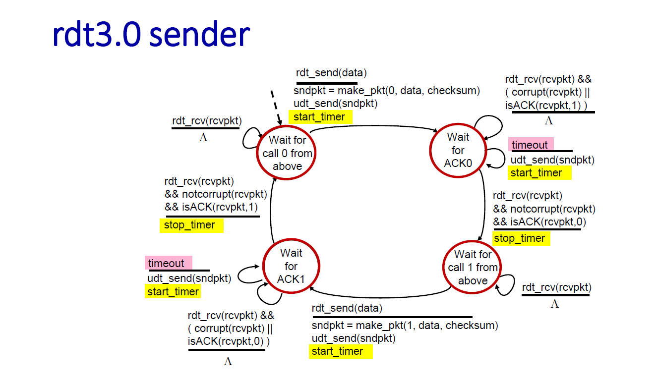
GO BACK N
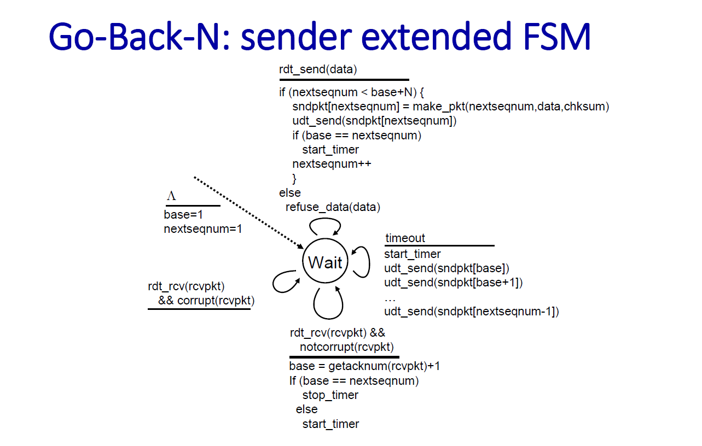
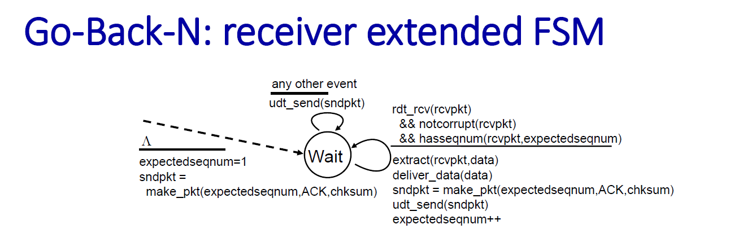
Selective Repeat
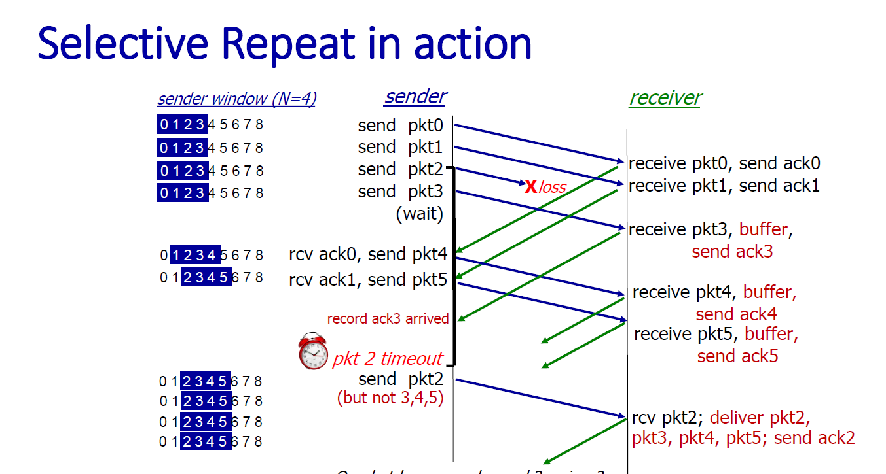

Complete code for RDT:
import random
import time
import math
def compute_packet_checksum(packet):
if packet['type'] == 'data':
data = packet.get('data', '')
seq = packet.get('seq', 0)
checksum_bytes = seq.to_bytes(4, byteorder='big') + data.encode()
elif packet['type'] == 'ack':
ack_seq = packet.get('ack_seq', 0)
checksum_bytes = ack_seq.to_bytes(4, byteorder='big')
else:
return 0
checksum = sum(checksum_bytes) & 0xFFFFFFFF
return checksum
def create_data_packet(seq, data):
packet = {'type': 'data', 'seq': seq, 'data': data}
packet['checksum'] = compute_packet_checksum(packet)
return packet
def create_ack_packet(ack_seq):
packet = {'type': 'ack', 'ack_seq': ack_seq}
packet['checksum'] = compute_packet_checksum(packet)
return packet
def is_corrupted(packet):
saved_checksum = packet.get('checksum', 0)
temp_packet = packet.copy()
temp_packet.pop('checksum', None)
computed_checksum = compute_packet_checksum(temp_packet)
return saved_checksum != computed_checksum
###############################
# Simulated Unreliable Network
###############################
class Network:
def __init__(self, loss_prob, corrupt_prob, delay_prob, max_delay, packet_size):
self.loss_prob = loss_prob
self.corrupt_prob = corrupt_prob
self.delay_prob = delay_prob
self.max_delay = max_delay
self.packets_in_transit = [] # list of (delivery_time, packet, dest)
# Transmission time: 10 bytes -> 5 ms
self.transfer_time = math.ceil(packet_size / 10) * 5
def send_packet(self, packet, current_time, dest):
pid = f"{packet['type']}(seq={packet.get('seq', packet.get('ack_seq'))})"
# Simulate loss
if random.random() < self.loss_prob:
print(f"[{current_time} ms] Network: {pid} to {dest} lost")
return
# Simulate corruption
if random.random() < self.corrupt_prob:
packet = self.corrupt_packet(packet)
print(f"[{current_time} ms] Network: {pid} to {dest} corrupted")
# Simulate delay
if random.random() < self.delay_prob and self.max_delay > 0:
net_delay = random.randint(1, self.max_delay)
print(f"[{current_time} ms] Network: {pid} to {dest} network delay {net_delay} ms")
else:
net_delay = 0
delivery_time = current_time + net_delay + self.transfer_time
print(f"[{current_time} ms] Network: {pid} to {dest} scheduled at {delivery_time} ms (tx {self.transfer_time} ms)")
self.packets_in_transit.append((delivery_time, packet, dest))
def corrupt_packet(self, packet):
if packet['type'] == 'data':
seq = packet['seq']
new_seq = seq + 1
return create_data_packet(new_seq, packet['data'])
else:
ack = packet['ack_seq']
new_ack = ack + 1
return create_ack_packet(new_ack)
def receive_packets(self, current_time, dest):
delivered = []
remaining = []
for (t, pkt, d) in self.packets_in_transit:
if d != dest:
remaining.append((t, pkt, d))
elif t <= current_time:
delivered.append(pkt)
else:
remaining.append((t, pkt, d))
self.packets_in_transit = remaining
return delivered
####################################
# rdt 3.0 (Stop-and-Wait) Protocol
####################################
class RDT30Sender:
def __init__(self, timeout):
self.timeout = timeout
self.next_seq = 0
self.current_packet = None
self.timer_start = -1
self.waiting_for_ack = False
def send(self, data, current_time):
self.current_packet = create_data_packet(self.next_seq, data)
self.timer_start = current_time
self.waiting_for_ack = True
return self.current_packet
def handle_ack(self, ack_packet, current_time):
if (not self.waiting_for_ack or ack_packet['type'] != 'ack' or is_corrupted(ack_packet)):
return False
if ack_packet['ack_seq'] == self.next_seq:
self.next_seq = 1 - self.next_seq
self.waiting_for_ack = False
return True
return False
def check_timeout(self, current_time):
return self.waiting_for_ack and (current_time - self.timer_start) >= self.timeout
class RDT30Receiver:
def __init__(self):
self.expected_seq = 0
self.delivered_data = []
def handle_packet(self, packet):
if packet['type'] != 'data' or is_corrupted(packet):
return None
seq = packet['seq']
if seq == self.expected_seq:
self.delivered_data.append(packet['data'])
self.expected_seq = 1 - self.expected_seq
return create_ack_packet(seq)
####################################
# Go-Back-N (GBN) Protocol
####################################
class GBNSender:
def __init__(self, window_size, timeout):
self.window_size = window_size
self.timeout = timeout
self.base = 0
self.next_seq = 0
self.packets = []
self.timers = {}
def send_packets(self, current_time, network):
while (self.next_seq < self.base + self.window_size) and (self.next_seq < len(self.packets)):
packet = self.packets[self.next_seq]
print(f"[{current_time} ms] GBNSender: sending seq={packet['seq']}")
network.send_packet(packet, current_time, 'receiver')
if self.next_seq not in self.timers:
self.timers[self.next_seq] = current_time
self.next_seq += 1
def handle_ack(self, ack_packet, current_time):
if ack_packet['type'] != 'ack' or is_corrupted(ack_packet):
return False
ack_seq = ack_packet['ack_seq']
print(f"[{current_time} ms] GBNSender: received ack={ack_seq}")
for i in range(self.base, self.next_seq):
if self.packets[i]['seq'] == ack_seq:
self.base = i + 1
for seq in list(self.timers.keys()):
if seq < self.base:
del self.timers[seq]
break
return True
def check_timeout(self, current_time):
if self.base >= len(self.packets):
return False
send_time = self.timers.get(self.base)
if send_time is not None and (current_time - send_time) >= self.timeout:
print(f"[{current_time} ms] GBNSender: timeout, resending from base={self.base}")
self.next_seq = self.base
self.timers.clear()
return True
return False
class GBNReceiver:
def __init__(self):
self.expected_seq = 0
self.delivered_data = []
def handle_packet(self, packet):
if packet['type'] != 'data' or is_corrupted(packet):
return None
seq = packet['seq']
print(f"[Receiver] got seq={seq}, expected={self.expected_seq}")
if seq == self.expected_seq:
self.delivered_data.append(packet['data'])
self.expected_seq += 1
return create_ack_packet(seq)
else:
last_ack = max(self.expected_seq - 1, 0)
return create_ack_packet(last_ack)
####################################
# Selective Repeat (SR) Protocol
####################################
class SRSender:
def __init__(self, window_size, timeout):
self.window_size = window_size
self.timeout = timeout
self.base = 0
self.next_seq = 0
self.packets = []
self.timers = {}
self.acked = set()
def send_packets(self, current_time, network):
while (self.next_seq < self.base + self.window_size) and (self.next_seq < len(self.packets)):
if self.next_seq not in self.acked:
packet = self.packets[self.next_seq]
print(f"[{current_time} ms] SRSender: sending seq={packet['seq']}")
network.send_packet(packet, current_time, 'receiver')
if self.next_seq not in self.timers:
self.timers[self.next_seq] = current_time
self.next_seq += 1
def handle_ack(self, ack_packet, current_time):
if ack_packet['type'] != 'ack' or is_corrupted(ack_packet):
return False
ack_seq = ack_packet['ack_seq']
print(f"[{current_time} ms] SRSender: got ack={ack_seq}")
for i in range(self.base, min(self.base + self.window_size, len(self.packets))):
if self.packets[i]['seq'] == ack_seq and i not in self.acked:
self.acked.add(i)
del self.timers[i]
break
while self.base in self.acked:
self.base += 1
return True
def check_timeout(self, current_time):
timed_out = False
for seq, send_time in list(self.timers.items()):
if (current_time - send_time) >= self.timeout:
print(f"[{current_time} ms] SRSender: timeout seq={seq}, retransmitting")
self.timers[seq] = current_time
timed_out = True
return timed_out
class SRReceiver:
def __init__(self, window_size):
self.window_size = window_size
self.base = 0
self.buffer = {}
self.delivered_data = []
def handle_packet(self, packet):
if packet['type'] != 'data' or is_corrupted(packet):
return None
seq = packet['seq']
print(f"[SRReceiver] got seq={seq}, window=[{self.base},{self.base+self.window_size-1}]")
if self.base <= seq < self.base + self.window_size:
self.buffer[seq] = packet['data']
while self.base in self.buffer:
self.delivered_data.append(self.buffer.pop(self.base))
self.base += 1
return create_ack_packet(seq)
elif seq < self.base:
return create_ack_packet(seq)
return None
###########################
# Simulation Routines
###########################
MAX_SIMULATION_STEPS = 10000
def simulate_rdt30(packets_to_send, loss, corrupt, delay_prob, max_delay, packet_size, timeout):
network = Network(loss, corrupt, delay_prob, max_delay, packet_size)
sender = RDT30Sender(timeout)
receiver = RDT30Receiver()
current_time = 0
current_idx = 0
while (current_idx < len(packets_to_send) or sender.waiting_for_ack) and current_time < MAX_SIMULATION_STEPS:
# Receiver side
for pkt in network.receive_packets(current_time, 'receiver'):
print(f"[{current_time} ms] Receiver: got seq={pkt['seq']}")
ack = receiver.handle_packet(pkt)
if ack:
print(f"[{current_time} ms] Receiver: sending ack={ack['ack_seq']}")
network.send_packet(ack, current_time, 'sender')
# Sender side
for ack in network.receive_packets(current_time, 'sender'):
print(f"[{current_time} ms] Sender: got ack={ack['ack_seq']}")
if sender.handle_ack(ack, current_time):
current_idx += 1
if sender.check_timeout(current_time):
seq = sender.current_packet['seq']
print(f"[{current_time} ms] Sender: timeout seq={seq}, retransmitting")
network.send_packet(sender.current_packet, current_time, 'receiver')
sender.timer_start = current_time
if not sender.waiting_for_ack and current_idx < len(packets_to_send):
data = packets_to_send[current_idx]
pkt = sender.send(data, current_time)
print(f"[{current_time} ms] Sender: sending seq={pkt['seq']} data='{data}'")
network.send_packet(pkt, current_time, 'receiver')
current_time += 1
return receiver.delivered_data, current_time
def simulate_gbn(packets_to_send, window_size, loss, corrupt, delay_prob, max_delay, packet_size, timeout):
network = Network(loss, corrupt, delay_prob, max_delay, packet_size)
sender = GBNSender(window_size, timeout)
sender.packets = [create_data_packet(i, data) for i, data in enumerate(packets_to_send)]
receiver = GBNReceiver()
current_time = 0
while sender.base < len(packets_to_send) and current_time < MAX_SIMULATION_STEPS:
for pkt in network.receive_packets(current_time, 'receiver'):
print(f"[{current_time} ms] Receiver: got seq={pkt['seq']}")
ack = receiver.handle_packet(pkt)
if ack:
print(f"[{current_time} ms] Receiver: sending ack={ack['ack_seq']}")
network.send_packet(ack, current_time, 'sender')
for ack in network.receive_packets(current_time, 'sender'):
sender.handle_ack(ack, current_time)
sender.check_timeout(current_time)
sender.send_packets(current_time, network)
current_time += 1
return receiver.delivered_data, current_time
def simulate_sr(packets_to_send, window_size, loss, corrupt, delay_prob, max_delay, packet_size, timeout):
network = Network(loss, corrupt, delay_prob, max_delay, packet_size)
sender = SRSender(window_size, timeout)
sender.packets = [create_data_packet(i, data) for i, data in enumerate(packets_to_send)]
receiver = SRReceiver(window_size)
current_time = 0
while sender.base < len(packets_to_send) and current_time < MAX_SIMULATION_STEPS:
for pkt in network.receive_packets(current_time, 'receiver'):
print(f"[{current_time} ms] SRReceiver: got seq={pkt['seq']}")
ack = receiver.handle_packet(pkt)
if ack:
print(f"[{current_time} ms] SRReceiver: sending ack={ack['ack_seq']}")
network.send_packet(ack, current_time, 'sender')
for ack in network.receive_packets(current_time, 'sender'):
sender.handle_ack(ack, current_time)
sender.check_timeout(current_time)
sender.send_packets(current_time, network)
current_time += 1
return receiver.delivered_data, current_time
def main():
print("Reliable Data Transfer Protocol Simulation")
print("1. rdt3.0 (Stop-and-Wait)")
print("2. Go-Back-N (GBN)")
print("3. Selective Repeat (SR)")
choice = input("Enter protocol choice (1/2/3): ").strip()
num_packets = int(input("Number of packets to send: "))
loss = float(input("Loss probability (0-1): "))
corrupt = float(input("Corruption probability (0-1): "))
delay_prob = float(input("Delay probability (0-1): "))
max_delay = int(input("Maximum network delay (ms): "))
packet_size = int(input("Packet size (bytes): "))
timeout = 10 # fixed timeout in ms
window_size = 1
if choice in ['2', '3']:
window_size = int(input("Window size: "))
packets = [f"Packet_{i}" for i in range(num_packets)]
start_wall_time = time.time()
if choice == '1':
delivered, sim_steps = simulate_rdt30(packets, loss, corrupt, delay_prob, max_delay, packet_size, timeout)
elif choice == '2':
delivered, sim_steps = simulate_gbn(packets, window_size, loss, corrupt, delay_prob, max_delay, packet_size, timeout)
elif choice == '3':
delivered, sim_steps = simulate_sr(packets, window_size, loss, corrupt, delay_prob, max_delay, packet_size, timeout)
else:
print("Invalid choice")
return
end_wall_time = time.time()
print("\nSimulation Results:")
print("Original Packets:", packets)
print("Delivered Packets:", delivered)
print("Data Match:", "Success" if delivered == packets else "Failure")
print(f"Simulation Time: {sim_steps} ms")
if __name__ == "__main__":
main()

Note:
- Packet Size of 10 bytes takes 5ms to Transfer
- Timeout is fixed to 10ms.
Testing for RDT 3.0 (Stop and Wait)
Ideal Scenario:
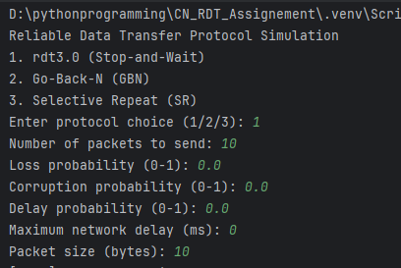
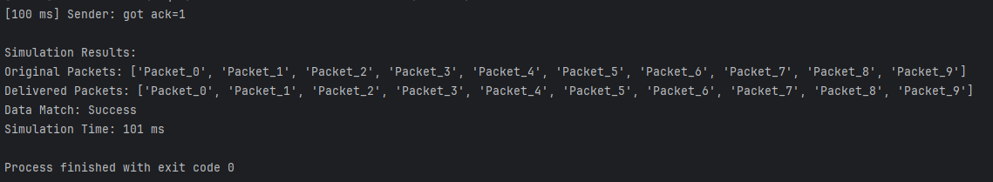

Loss only (10%):
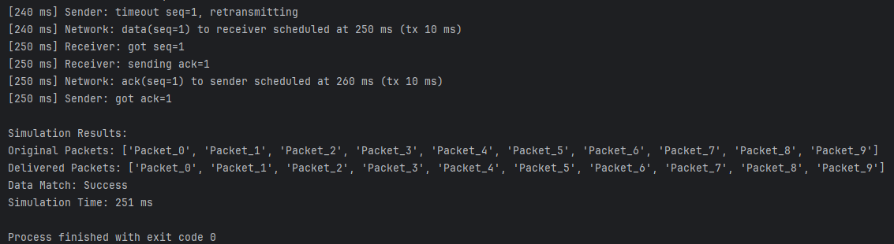
Corruption only (10%):
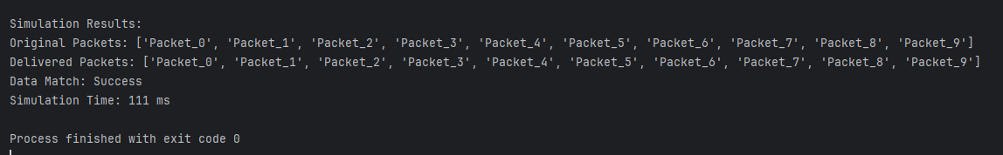
Delay only (30%, up to 20 ms):
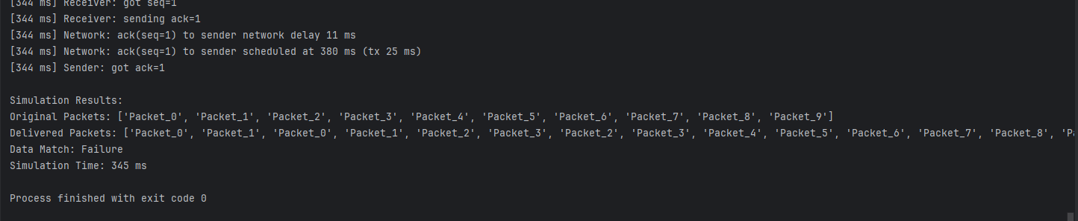
High‐error stress test:
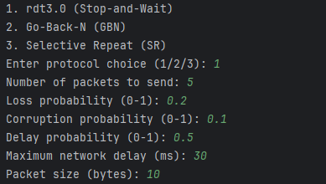
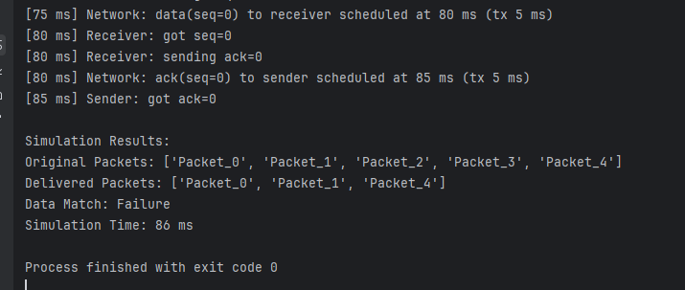
Large transfer:
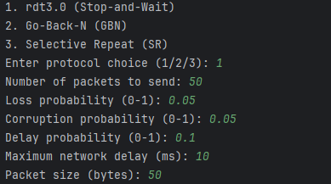
49 out of 50 packets were delivered.
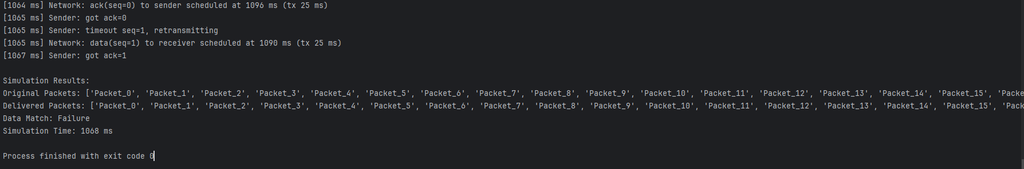
GO Back N Testing:
Ideal Transfer:
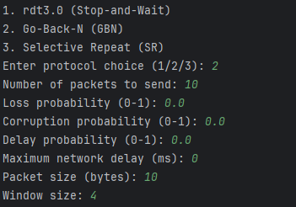
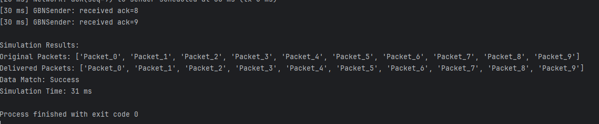

Loss only (10%):
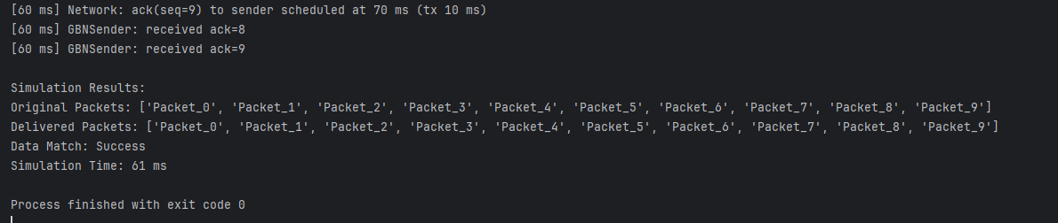
Corruption only (10%):
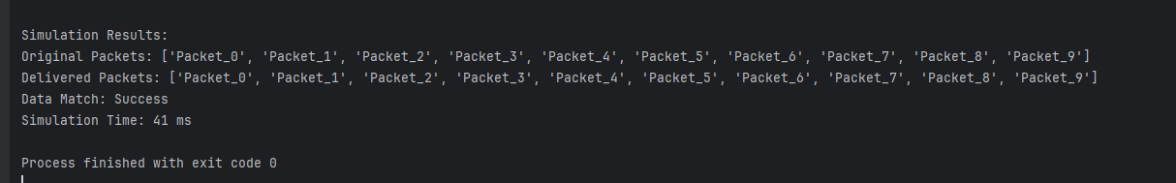
Delay only (30%, up to 20 ms):
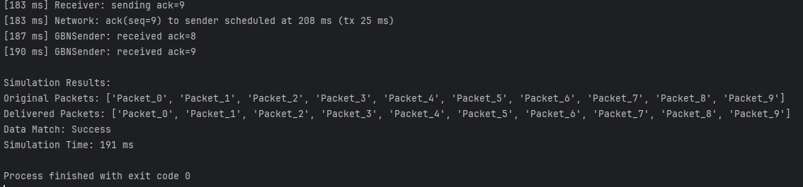
High‐error stress test:
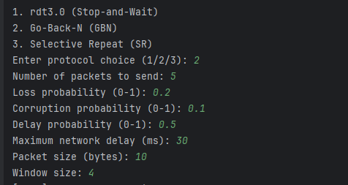
Packet 2 lost out of 5 packets
Still not received after retransmission.
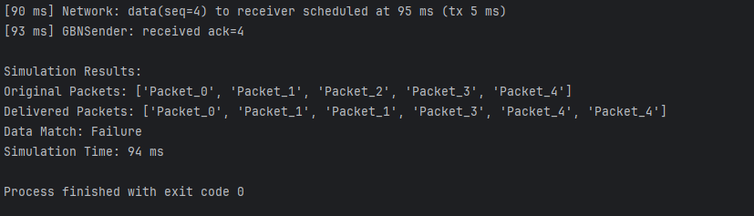
Large transfer:
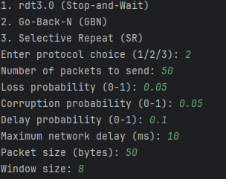
Packet 11 corrupted during transmission.
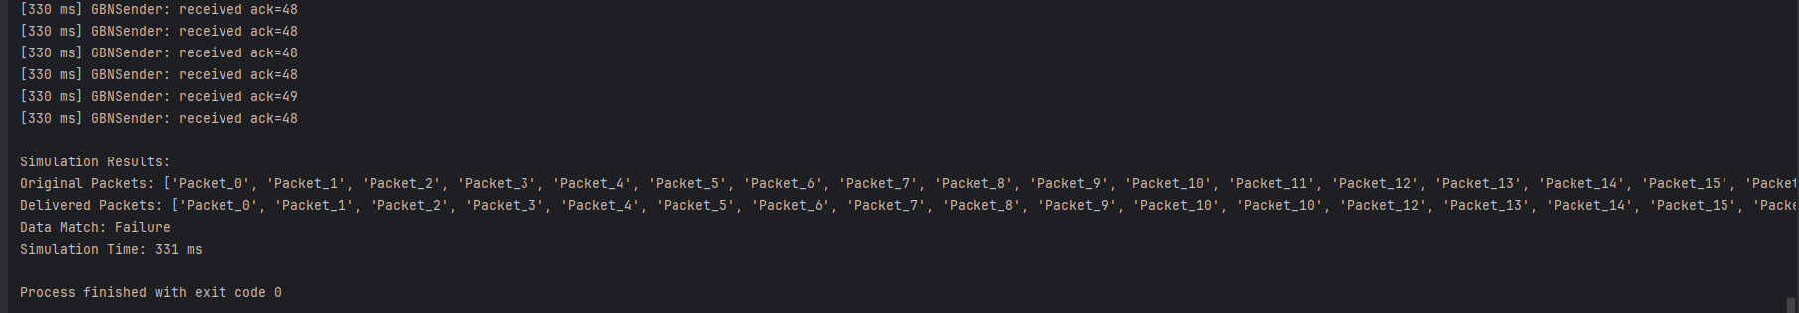
Selective Repeat Testing

Ideal network (No loss/delay/corruption):
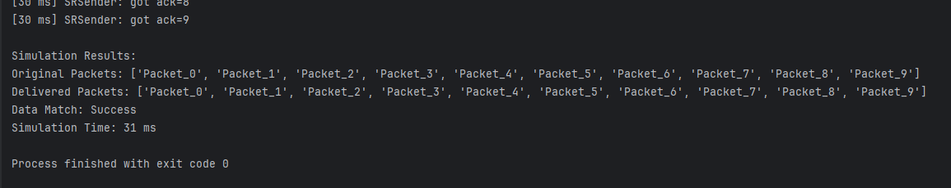

Loss only (10%):
5 packets lost and after retransmitting for 10000ms they were still not received.
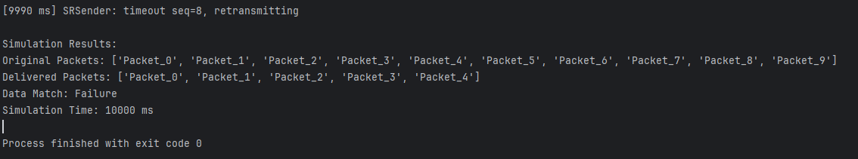
Corruption only (10%):
6 packets out of 10 were corrupted.
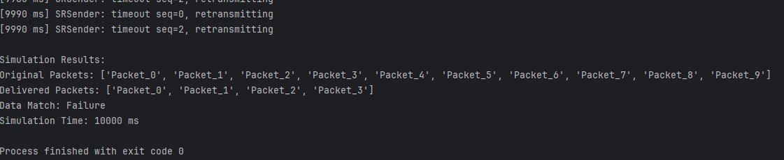
Delay only (30%, up to 20 ms):
success
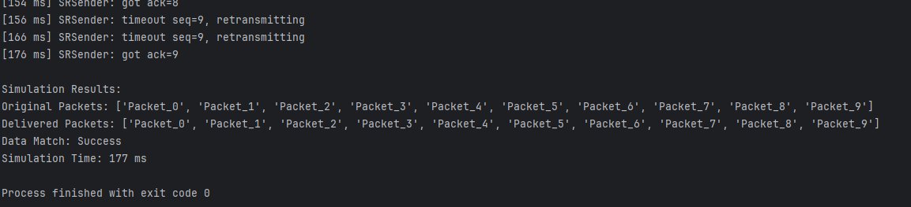
High‐error stress test:
Success
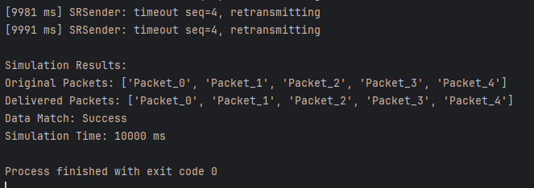
Large transfer:
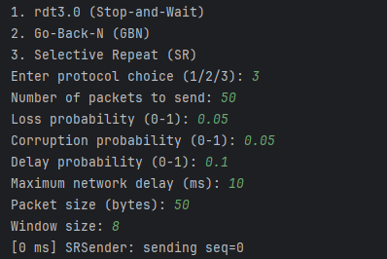
50 packets, Failed to retransmit in 10000ms.
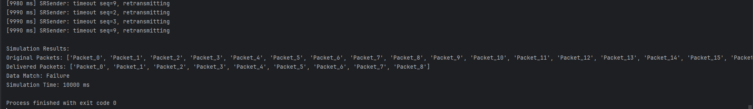

Conclusion
This simulation provides a hands-on understanding of how reliable protocols function under unreliable network conditions. The modularity and parameterized design make it easy to extend or modify for educational purposes or deeper protocol analysis.

